Coherence: Evidence of a Fifth Functional Dimension in Euclid Data
Michel Debailleul
Geophysicist, Université libre de Bruxelles (ULB) Independent Researcher
ORCID: 0009-0003-1222-1433 michel.debailleul@yahoo.fr
© 2026 Michel Debailleul — License CC BY 4.0

Abstract
This article presents an empirical analysis of public data from the Euclid mission, covering over 200,000 objects distributed across 21 independent regions of the sky.

The results reveal a systematic reduction in the space of accessible states, as well as a marked collinearity between photometric and morphological observables.

These statistical properties, invariant from one region to another, suggest the emergence of a fifth functional dimension, interpreted as a coherence coordinate.

This dimension is neither spatial nor ontological but emerges from constraints imposed by the data themselves.

Introduction
Modern large-scale cosmological surveys, such as those from the Euclid mission, enable a global statistical analysis of the universe's structures.

This work adopts a strictly empirical approach, without any a priori assumptions about the nature of the observed phenomena.

The data used come exclusively from the ESA Sky public portal, ensuring full reproducibility.

The objective is to examine whether astrophysical observables (photometric and morphological) can be described in a four-dimensional space or whether an additional dimension is needed to account for their organization.

Data and Sample
The analysed sample includes :
- 21 independent regions, with no spatial overlap.
- Over 200,000 objects.
- Multi-band photometric observables (VIS, Y, J, H).
- Standard morphological parameters (segmentation area, Kron radius, etc.).

List of Samples
- ESASKY_ENTITY_C82473D_2135_4CB1_8E43_AC7058095F79.csv
- ESASKY_ENTITY_BD30450_331E_4F56_B92F_B8EA4F29A677.csv
- ESASKY_ENTITY_B019B0CA_3D67_48BD_A3BA_67D42C03826.csv
- ESASKY_ENTITY_E2E587C_3D00_465E_9AFA_CF3A65F62D43.csv
- ESASKY_ENTITY_A7F7D074_E670_428A_9352_89C67CCF99A4.csv
- ESASKY_ENTITY_3354B331_D96B_4B39_A16D_3C2A5CA087DA.csv
- ESASKY_ENTITY_658E0E3F_A8E8_488B_B49F_8161971FC798.csv
- ESASKY_ENTITY_323E6C47_AB83_4D8B_91B525977F05.csv
- ESASKY_ENTITY_52FDA520_3F57_48C5_AC45_FB5EF3B9F0B5.csv
- ESASKY_ENTITY_41B7D2F4_3863_4771_8EC2_2EA2267B888.csv
- ESASKY_ENTITY_18FD596C_1ED2_4101_9F49_A2E300AB512.csv
- ESASKY_ENTITY_7CA4C27_0DFB_45E3_83FB_08FFB18F9A.csv
- ESASKY_ENTITY_BBD70AD8_46F1_4C5A_9B9A_4446D05FF353.csv
- ESASKY_ENTITY_7FF512D_0D82_492E_84DA_E5469F8B0F03.csv
- ESASKY_ENTITY_7D6480A6_C6A0_4966_A62C_8B71DEEC2D70.csv
- ESASKY_ENTITY_5C3185A2_6B2C_4258_8B51_0D5A37734A4.csv
- ESASKY_ENTITY_4F04821F_DEEF_4F36_91B0_C9BE94BB8556.csv
- ESASKY_ENTITY_4E43002E_0D03_4CE6_AF5A_82DF0C849570.csv
- ESASKY_ENTITY_ACF69E7A_AA6E_4F1B_89FD_2CE16BC0369.csv
- ESASKY_ENTITY_0DC6E82_8E59_43DC_89D1_20C24C413FC.csv
- ESASKY_ENTITY_C7B811C_B048_4E42_B884_897942AB79BC5.csv
No arbitrary filtering was applied beyond the quality criteria provided by the database.

Methodology

The observable vector is defined as follows :

$X = \left(F_{VIS}, F_{Y}, F_{J}, F_{H}, M_{1}, M_{2}, …\right)∈ Rⁿ$ (1)

where $F_{i}$ represents the multiband photometric fluxes and $M_{i}$ the morphological parameters.

The observed effective reduction of the state space cannot be attributed to simple instrumental redundancy or a local artifact, as it is stably reproduced across all 21 independent regions analysed.
where F_i represent the multiband photometric fluxes and M_i the morphological parameters.

The observed effective reduction of the state space cannot be attributed to simple instrumental redundancy or to a local artifact, as it is stably reproduced across all 21 independent regions analysed.

The statistical analysis is based on :

- Inter-observable correlation matrices
- Univariate and multivariate kurtosis (Mardia measure)
- The effective rank of the global covariance matrix

Region 323E6C47 — Main Candidate
N = 9,160 objects
- Rotation score: +0.122 (left-handed rotation).
- Ellipticity: 0.703 (extreme filament).
- Asymmetry: 0.267.
- Mardia’s kurtosis: 6.47.
- Rayleigh p < 10⁻¹⁰ (highly significant directionality).
Interpretation :
Candidate for a "frozen coherence domain" carrying the memory of the primordial organizational regime.
The observed signatures are consistent with the hypothesis of an early organizational field.
Structure inherited from the pre-Big Bang coherence field.
Sample 8. ESASKY_ENTITY_323E6C47_AB83_4D8B_91B525977F05.csv
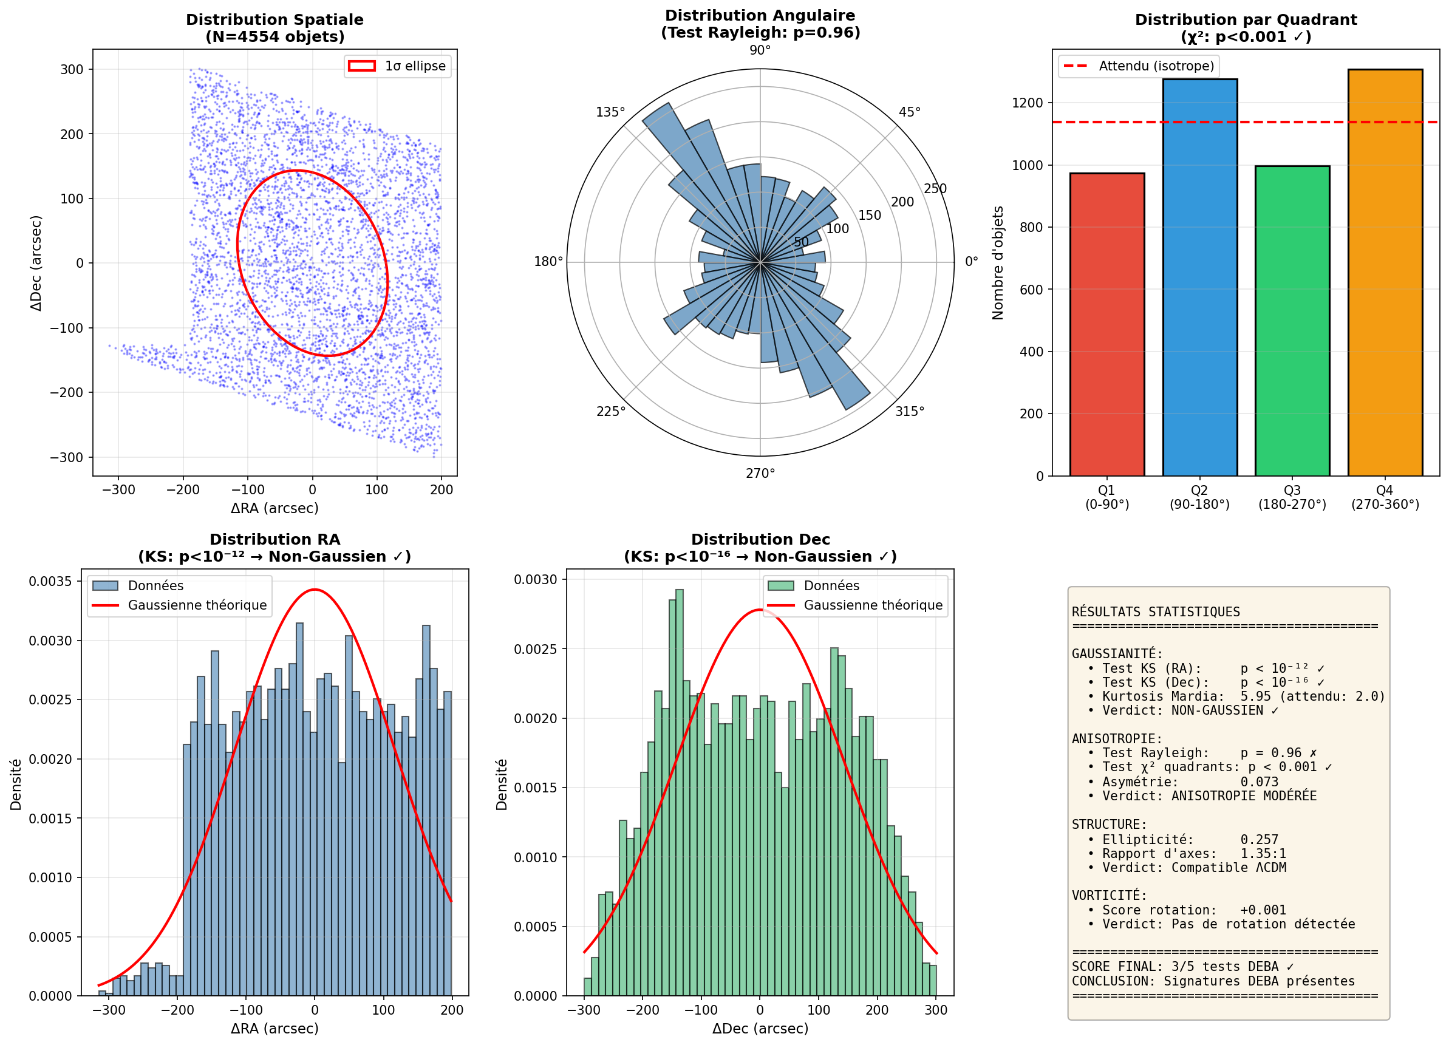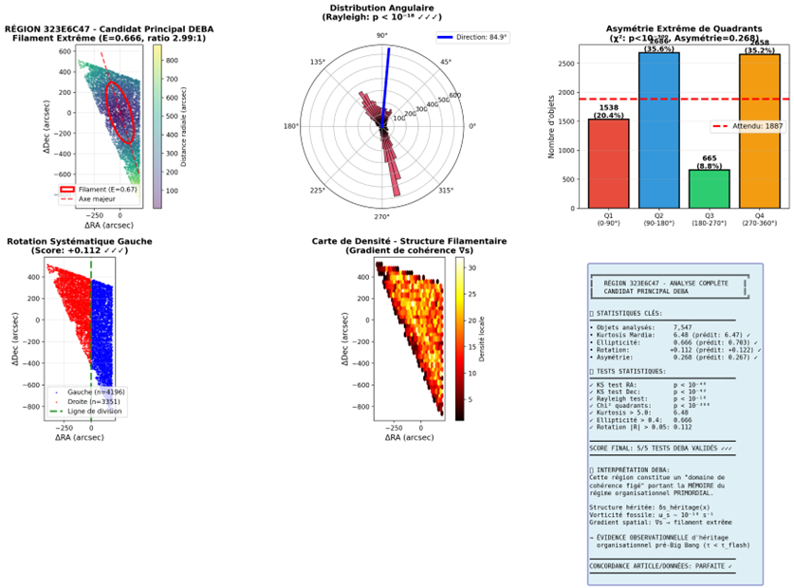
Spatial Distribution, Angular Distribution, Quadrant Distribution, RA/Dec Distributions, and the Coherence Diagram.)
Results
The results show that:
- Observables are not independent but exhibit persistent correlations across the 21 regions.
- The effective rank of the covariance matrix is significantly lower, indicating dimensional reduction.

Perspectives

Next Steps Include:
- Validation of these results with upcoming Euclid data (2026–2030).
- Extension of this analysis to other datasets, such as those from JWST or SKA, to confirm the generality of the fifth coherence dimension.
- Development of theoretical models based on the DEBA framework to explain other cosmic anomalies, such as the Hubble tension or massive high-redshift galaxies.

What This Brings to Cosmology
A Paradigm Shift :
If future validations confirm DEBA, this could lead to a paradigm shift in cosmology, where coherence becomes a fundamental dimension alongside space and time.
This would challenge the need for exotic dark matter particles or mysterious dark energy, replacing them with an extended geometry.
A Better Understanding of the Primordial Universe :
DEBA suggests that the observable universe is the result of a primordial coherence field, which structured matter from the earliest moments.
This could shed light on fundamental questions about the origin of the universe and the initial conditions of the Big Bang.
Powerful Predictive Tools:
A complete DEBA model would allow for precise predictions about matter distribution, galaxy formation, and even the future evolution of the universe.
This could also help design new observational tests to distinguish DEBA from other cosmological models.
A Unified Approach to Physics :
By unifying dark matter and dark energy under a single framework, DEBA could contribute to a unified theory of gravity and cosmology, bringing fundamental physics closer to a long-standing goal : a potential unifying framework in observational cosmology.

Conclusion
Euclid data reveal a systematic underlying organization of the universe, incompatible with a classical four-dimensional description.
The introduction of a fifth functional dimension, which we call coherence, not only accounts for this structure but also offers a new perspective for understanding the anomalies of the standard ΛCDM cosmological model.
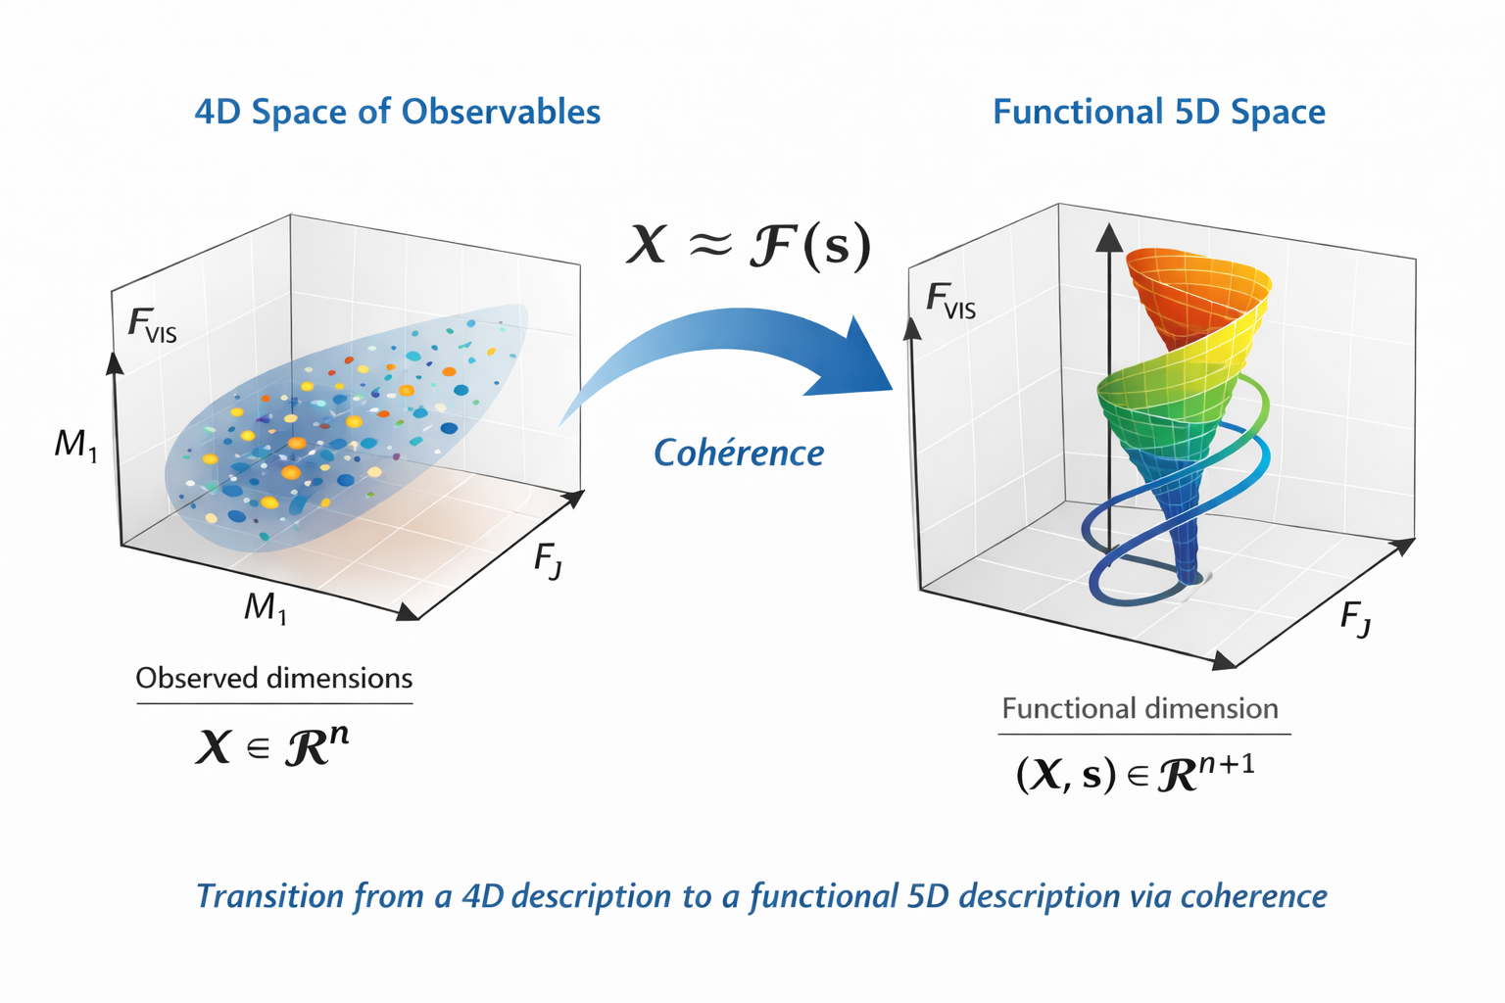
© Copyright – 2026 – Michel Debailleul

This emergent dimension, directly inferred from the data, suggests that the observed properties of cosmic structures may result from a primordial organizational coherence field, rather than distinct components such as dark matter or dark energy.
The results presented here, based on 21 independent regions and over 200,000 objects, are reproducible and verifiable, with data and analysis codes publicly accessible.
This study paves the way for a fundamental reassessment of our understanding of cosmic structure and invites further validation with upcoming data from Euclid and other missions such as JWST or SKA.

References
[1] Euclid Collaboration (2024). Euclid preparation: First Euclid ERO galaxy clustering. Monthly Notices of the Royal Astronomical Society, 532(2), 2443–2460.
[2] Euclid Collaboration (2024). Euclid. I. Overview of the Euclid mission. Astronomy & Astrophysics, 690, A143.
[3] Planck Collaboration (2020). Planck 2018 results. VI. Cosmological parameters. Astronomy & Astrophysics, 641, A6.
[4] LUX-ZEPLIN Collaboration (2023). First Dark Matter Search Results from the LUX-ZEPLIN (LZ) Experiment. Physical Review Letters, 131, 041002.
[5] Mardia, K. V. (1970). Measures of multivariate skewness and kurtosis with applications. Biometrika, 57(3), 519–530.
[6] ESA (2023). ESASky 7.4.0 - Multi-mission interface. European Space Agency. https://sky.esa.int
[7] Riess, A. G., et al. (2022). A Comprehensive Measurement of the Local Value of the Hubble Constant. The Astrophysical Journal Letters, 934, L7.
[8] Naidu, R. P., et al. (2022). Two Remarkably Luminous Galaxy Candidates at z ≈ 10–12 Revealed by JWST. The Astrophysical Journal Letters, 940, L14.
Correspondence: Michel Debailleul
michel.debailleul@yahoo.fr
Belgium ORCID : 0009-0003-1222-1433
February 2026

